Fifth Grade Summer Reading Activity

Miami-Dade County Public Schools recognizes the importance of ensuring that students continue to strengthen reading skills and develop a passion for reading beyond instructional requirements. Independent summer reading of literary/non-fiction text helps prepare students to be successful in meeting more rigorous academic standards.

Books can be purchased online/ bookstores or checked out in Miami Dade Public libraries. There are also free platforms that allow students to participate in the District’s Summer Reading Initiative without incurring any additional cost. To access these books, follow these directions:
*Go to http://read.dadeschools.net/
*Click on

*Click on and click on

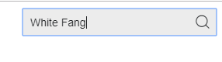
*In the search bar, you type the title of the book

The books chosen for incoming 5th graders are:
The Lemonade War by Jacqueline Davies
Surviving 5th grade by Charline Norton
Unschooled by Allan Woodrow
Bummer Summer by Dan Gutman
White Fang by Jack London
The Secret Garden by Frances Hodgson Burnett
MYON books 5th grade level is also acceptable*

Follow the directions below for the book your child chooses.
Directions:

- Your child should choose “one” book to read.
- Then, your child will choose “one” activity to do with the book he/she read.
- This assignment will be worth 2 grades and will be due Wednesday, August 31, 2022

Choose one activity to complete on the book your child chose to read.
Activities: Include student’s name, date, title, and author in every activity

- Write a character diary. Write at least “ten (10)” journal entries as if you were the main character in the story (see the sample reading log on the other side of this sheet). Write the events that happened and reflect on how the event affected the character and why. If you don’t have a printer, you may handwrite the character diary following the format shown.

- To complete a Summary Reading (10 entries minimum). See the sample reading summary on the other side of this sheet. If you do not have a printer, you may handwrite the Summaries. Summaries must follow the format shown include cover page with student’s name, date, title, and author.

- Create a timeline using drawings, magazine cutouts, computer graphics, pictures, and labels to show the main events, and how these events contribute to the meaning of the text.

Character Diary Sample (10 entries minimum):
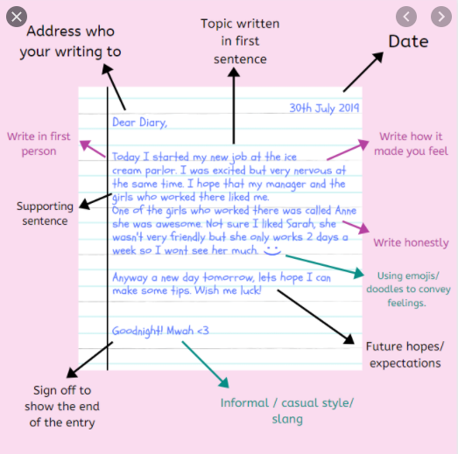

Reading Summary Sample (10 entries minimum):
Ch. 1 | Summary: ______________________________________________________________________________________________________________________________________________________________________________________________________________________________________________________________________________________________________________________________________________________________________________________________________________________________________________________
Ch. 2 | Summary: ______________________________________________________________________________________________________________________________________________________________________________________________________________________________________________________________________________________________________________________________________________________________________________________________________________________________________________________
Ch. 3 | Summary: _____________________________________________________________________________________________________________________________________________________________________________________________________________________________________________________________________________________________________________________________________________________________________________  _________________________________________________________________________

