Ms. Douyon
Supply List
2022-2023

- Book Bag (regular size- NO WHEELS/no mini-size)
- Change of clothes including socks (must be in a labeled large Ziploc bag)
- Small baby blanket (to be kept at school)
- Lunchbox (if not eating school lunch)
- Water Thermos (bring to school DAILY)
- 1 plastic container (shoe box size)
- Ziploc bags (gallon, quarter, sandwich size)
- 1 pack of crayons (24pk)
- 1 pack of markers (regular)
- 1 pack of colored permanent markers
- 1 pack of colored dry-erase markers
- 1 glue bottle (clear)
- 2 bottles of antibacterial soap
- 2 packs of baby wipes
- 1 box of tissue paper (Kleenex)
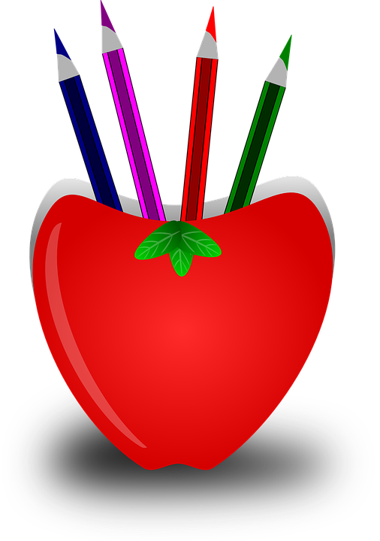
- 1 pack of white cardstock paper
- 1 pack of colored cardstock paper
- 1 Lysol spray
- 2 packs of Clorox/Lysol wipes

